**PRACTICAL NO: 2**

**AIM:INSERT THE DATA INTO**

**USE FYIT_40**

INSERT INTO CUSTOMER VALUES('C1','AKASH SINGH','MAIN STREET','DEHLI',239628,'HARIYANA',50000)

INSERT INTO CUSTOMER VALUES('C2','MAYUR RAI','RANADE ROAD','MUMBAI',400012,'MAHARASHTRA',45000)

INSERT INTO CUSTOMER VALUES('C3','SPARSH MEHTA','KAROL BAUG','DEHLI',678452,'HARIYANA',70000)

INSERT INTO CUSTOMER VALUES('C4','KUNAL THAKARE','LINK ROAD','MUMBAI',400032,'MAHARASHTRA',20000)

INSERT INTO CUSTOMER VALUES('C5','PANKAJ AKRE','SAWARKAR MARG','BANGLORE',223897,'KARNATAK',55000)

SELECT * FROM CUSTOMER

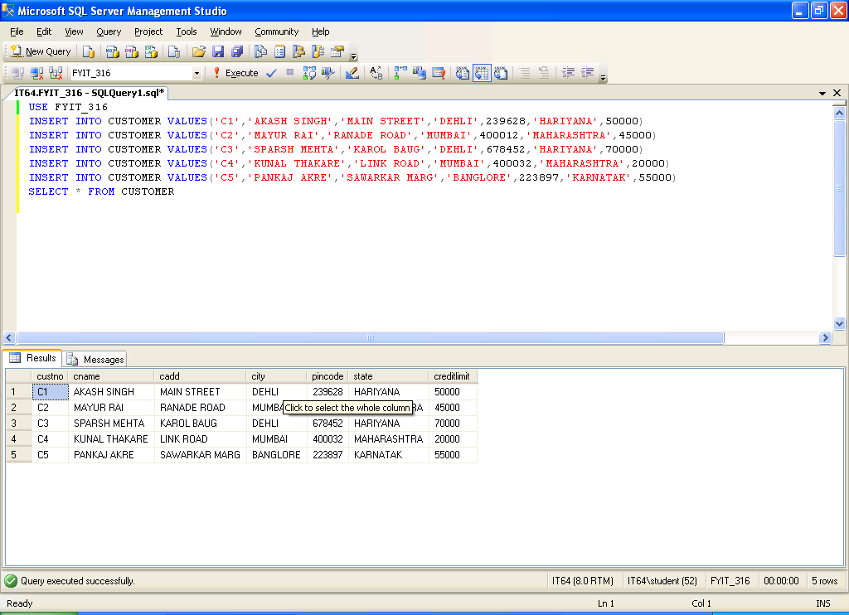

INSERT INTO PRODUCT VALUES('P1','T-SHIRTS',1,50,350,300)

INSERT INTO PRODUCT VALUES('P2','JEANS',1,45,1000,900)

INSERT INTO PRODUCT VALUES('P3','TROUSERS',1,60,670,550)

INSERT INTO PRODUCT VALUES('P4','SKIRTS',1,80,500,400)

INSERT INTO PRODUCT VALUES('P5','SHIRTS',1,65,2000,1500)

SELECT * FROM PRODUCT

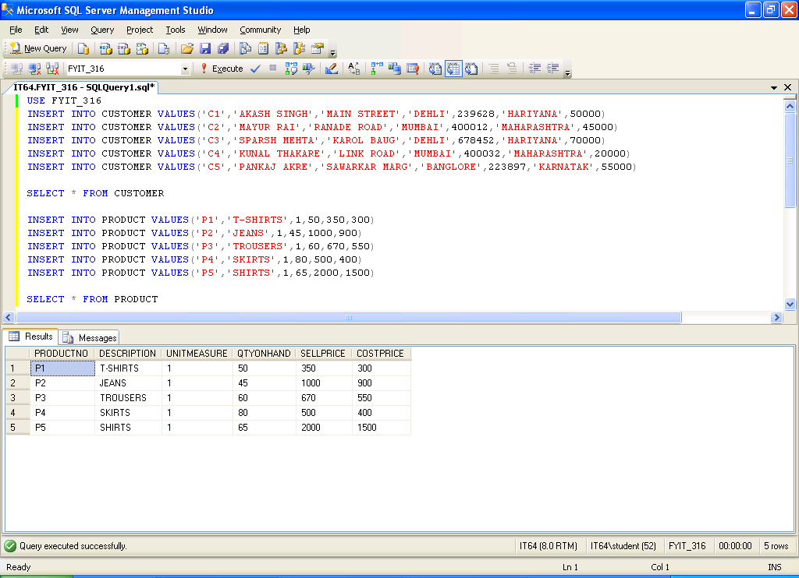

INSERT INTO SALESMASTER VALUES('S1','TARAL JAIN','R.J.CAMPUS','MUMBAI',400023,'MAHARASTRA',95000,100000)

INSERT INTO SALESMASTER VALUES('S2','ISHAN SINGH','S.V.ROAD','MUMBAI',400012,'MAHARASHTRA',200000,175000)

INSERT INTO SALESMASTER VALUES('S3','PARSHWA MEHTA','KAROL BAUG','DEHLI',623284,'HARIYANA',90000,75000)

INSERT INTO SALESMASTER VALUES('S4','RAJ MAHLOTRA','N.V.ROAD','BANGALORE',944423,'KARNATAK',50000,40000)

INSERT INTO SALESMASTER VALUES('S5','ANIRUDDHA MARATHE','LINK ROAD','MUMBAI',400032,'MAHARASHTRA',100000,85000)

SELECT * FROM SALESMASTER

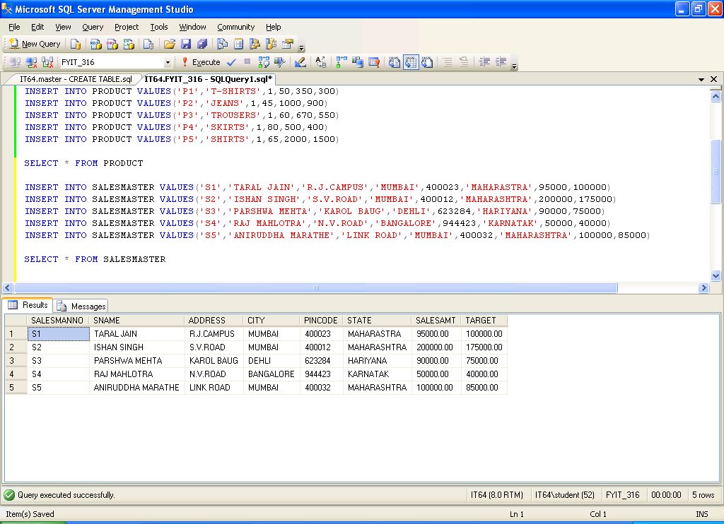

INSERT INTO SALESORDER VALUES('O1','C1','12-MAR-2010','S1','INPROCESS')

INSERT INTO SALESORDER VALUES('O2','C1','07-JUN-2010','S2','FULFILLED')

INSERT INTO SALESORDER VALUES('O3','C2','18-AUG-2010','S2','FULFILLED')

INSERT INTO SALESORDER VALUES('O4','C3','23-DEC-2009','S3','CANCELLED')

INSERT INTO SALESORDER VALUES('O5','C4','04-SEP-2010','S1','FULFILLED')

INSERT INTO SALESORDER VALUES('O6','C4','11-DEC-2010','S2','FULFILLED')

SELECT * FROM SALESORDER

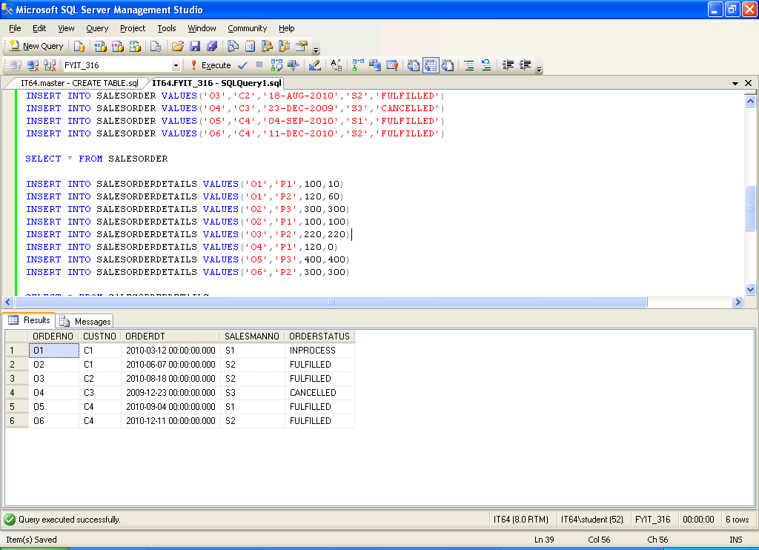

INSERT INTO SALESORDERDETAILS VALUES('O1','P1',100,10)

INSERT INTO SALESORDERDETAILS VALUES('O1','P2',120,60)

INSERT INTO SALESORDERDETAILS VALUES('O2','P3',300,300)

INSERT INTO SALESORDERDETAILS VALUES('O2','P1',100,100)

INSERT INTO SALESORDERDETAILS VALUES('O3','P2',220,220)

INSERT INTO SALESORDERDETAILS VALUES('O4','P1',120,0)

INSERT INTO SALESORDERDETAILS VALUES('O5','P3',400,400)

INSERT INTO SALESORDERDETAILS VALUES('O6','P2',300,300)

SELECT * FROM SALESORDERDETAILS

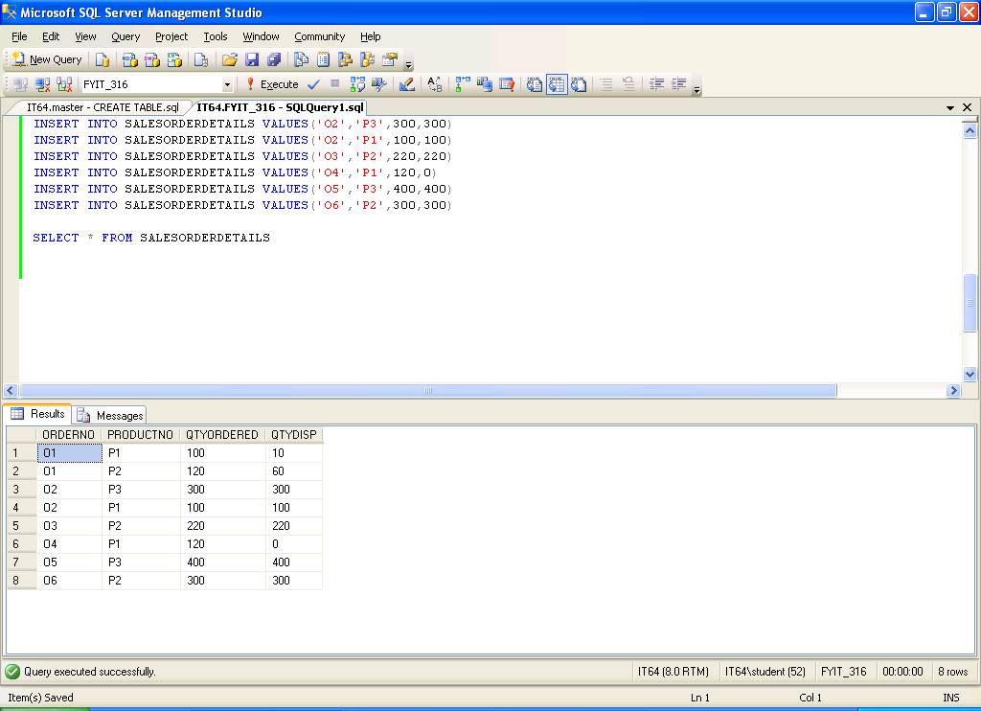

Q2. ADD A NEW FIELD CALLED 'ADDRESS2' TO THE CUSTOMER TABLE

ALTER TABLE CUSTOMER

ADD ADDRESS2 VARCHAR(30)

SELECT * FROM CUSTOMER

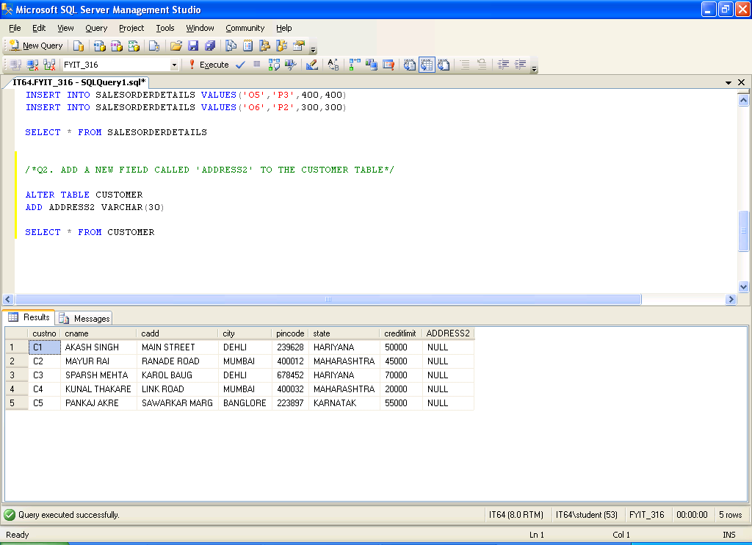

Q3. ADD A NEW FIELD 'TELEPHONE' OF DATATYPE INTEGER TO HTE SALESMANMASTER TABLE

ALTER TABLE SALESMASTER

ADD TELEPHONE INTEGER

SELECT * FROM SALESMASTER

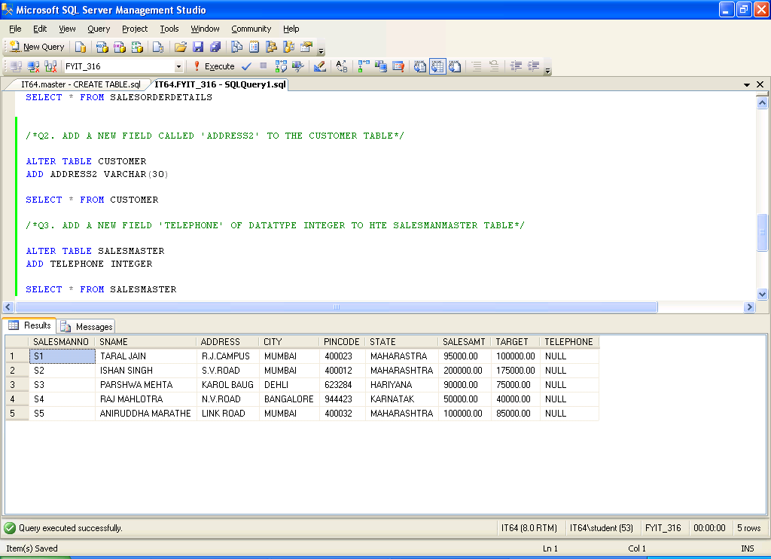

Q3. CHANGE THE CITY OF CUSTOMER NO. 'C4' TO 'BANGLORE'

UPDATE CUSTOMER

SET CITY='BANGLORE'

WHERE custno='C4'

SELECT * FROM CUSTOMER

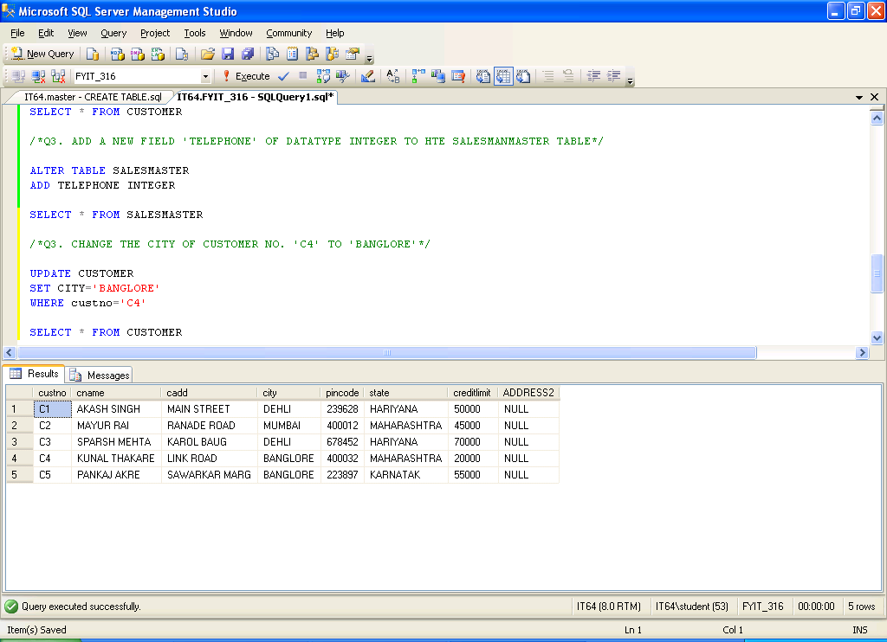

Q5. CHANGE THE COSTPRICE OF 'TROUSERS' TO Rs.500

UPDATE PRODUCT

SET COSTPRICE=500

WHERE DESCRIPTION='TROUSERS'

SELECT * FROM PRODUCT

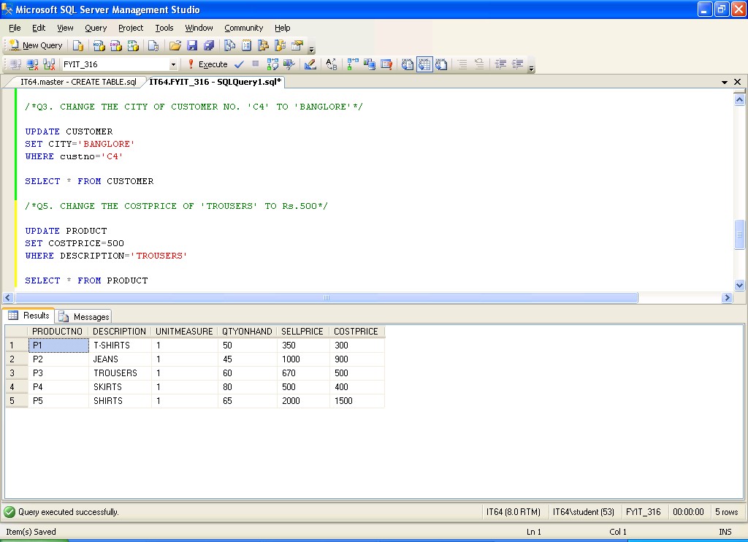

Q5. DELETE ALL THE PRODUCTS FROM PRODUCTMASTER WHERE SELLPRICE=Rs.500

DELETE FROM PRODUCT

WHERE SELLPRICE=500

SELECT * FROM PRODUCT

